Multi-Paradigm Problem Solving
Umama Azhar

An assignment submitted in partial fulfillment of the requirements for MSCS-632-A01 as part of the
degree Master of Science
In
Computer Science

School of Computing and Information Sciences
University of the Cumberlands
MSCS-632-A01: Advanced Programming Languages
Professor Jay Thom
June 23, 2026

Summer 2026

Introduction
The purpose of this project was to implement a statistics calculator that computes the mean, median, and mode of a list of integers using three different programming languages: C, OCaml, and Python. Each language was used to demonstrate a different programming paradigm: procedural programming in C, functional programming in OCaml, and object-oriented programming in Python. Although the problem remained the same, the implementation process differed significantly because each paradigm focuses on a different approach to organizing and solving problems.
Procedural Approach in C
The C implementation followed a procedural programming approach where the program was divided into separate functions for calculating the mean, median, mode, range, and standard deviation. The data was stored in an array, and operations such as sorting and counting frequencies were implemented manually. One challenge with C was that many operations that are automatically handled in higher-level languages had to be explicitly managed. For example, sorting logic and memory considerations required more attention. However, the procedural approach made it clear how the program executes step-by-step and how individual functions work together to produce the final result.
Functional Approach in OCaml
The OCaml implementation used a functional programming approach that focuses on immutable data and function-based transformations. Instead of using traditional loops and changing variables, list operations such as fold_left and recursive functions were used to process the data. The biggest difference from C was the emphasis on describing what should happen rather than explicitly controlling every step. The main challenge was adjusting to the functional style because it avoids mutable state and requires thinking about problems using functions and expressions. However, this approach resulted in concise and predictable code.
Object-Oriented Approach in Python
The Python implementation used an object-oriented design by creating a StatisticsCalculator class. The list of numbers was stored as an object attribute, and each calculation was implemented as a separate method. This approach organized the program by combining data and related behaviors into one structure. Python reduced implementation complexity because of its built-in data structures, such as lists and dictionaries, simplified data manipulation. The object-oriented approach also made the program easier to expand with additional features such as range and standard deviation.
Challenges and Key Differences
The main challenge of this project was adapting the same solution to three different programming paradigms. C required manual implementation of many operations, OCaml required a functional mindset using immutable data, and Python required organizing the solution around classes and objects. The procedural approach focuses on a sequence of instructions, the functional approach focuses on mathematical transformations, and the object-oriented approach focuses on organizing data and behavior together. Each paradigm has advantages depending on the type of problem being solved.

Conclusion
Implementing the statistics calculator in three languages demonstrated how programming paradigms influence software design. C provided a deeper understanding of low-level program control, OCaml demonstrated the benefits of functional programming and immutability, and Python showed how object-oriented programming can create organized and reusable code. Although all three implementations produced the same results, the development experience and structure of each solution were different.

References

Brookshear, J. G., & Brylow, D. (2019). Computer science: An overview (13th ed.). Pearson.
Sebesta, R. W. (2019). Concepts of programming languages (12th ed.). Pearson.
Python Software Foundation. (2025). The Python tutorial. https://docs.python.org/3/tutorial/
OCaml. (2025). The OCaml system: Documentation and resources. https://ocaml.org/

Program and Output in C

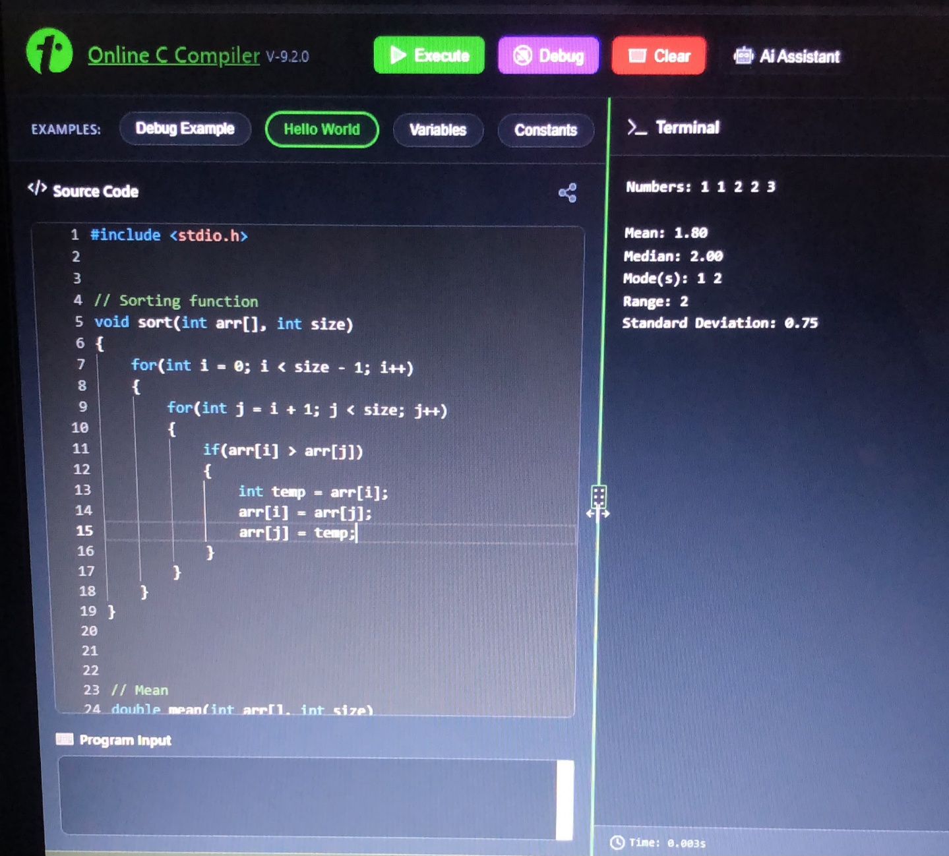

Program and Output in OCaml

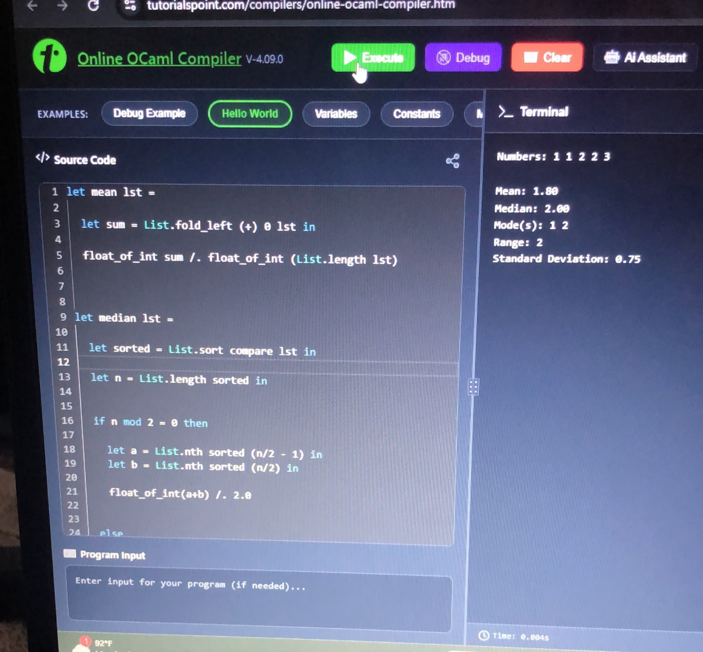

Program and Output in Python

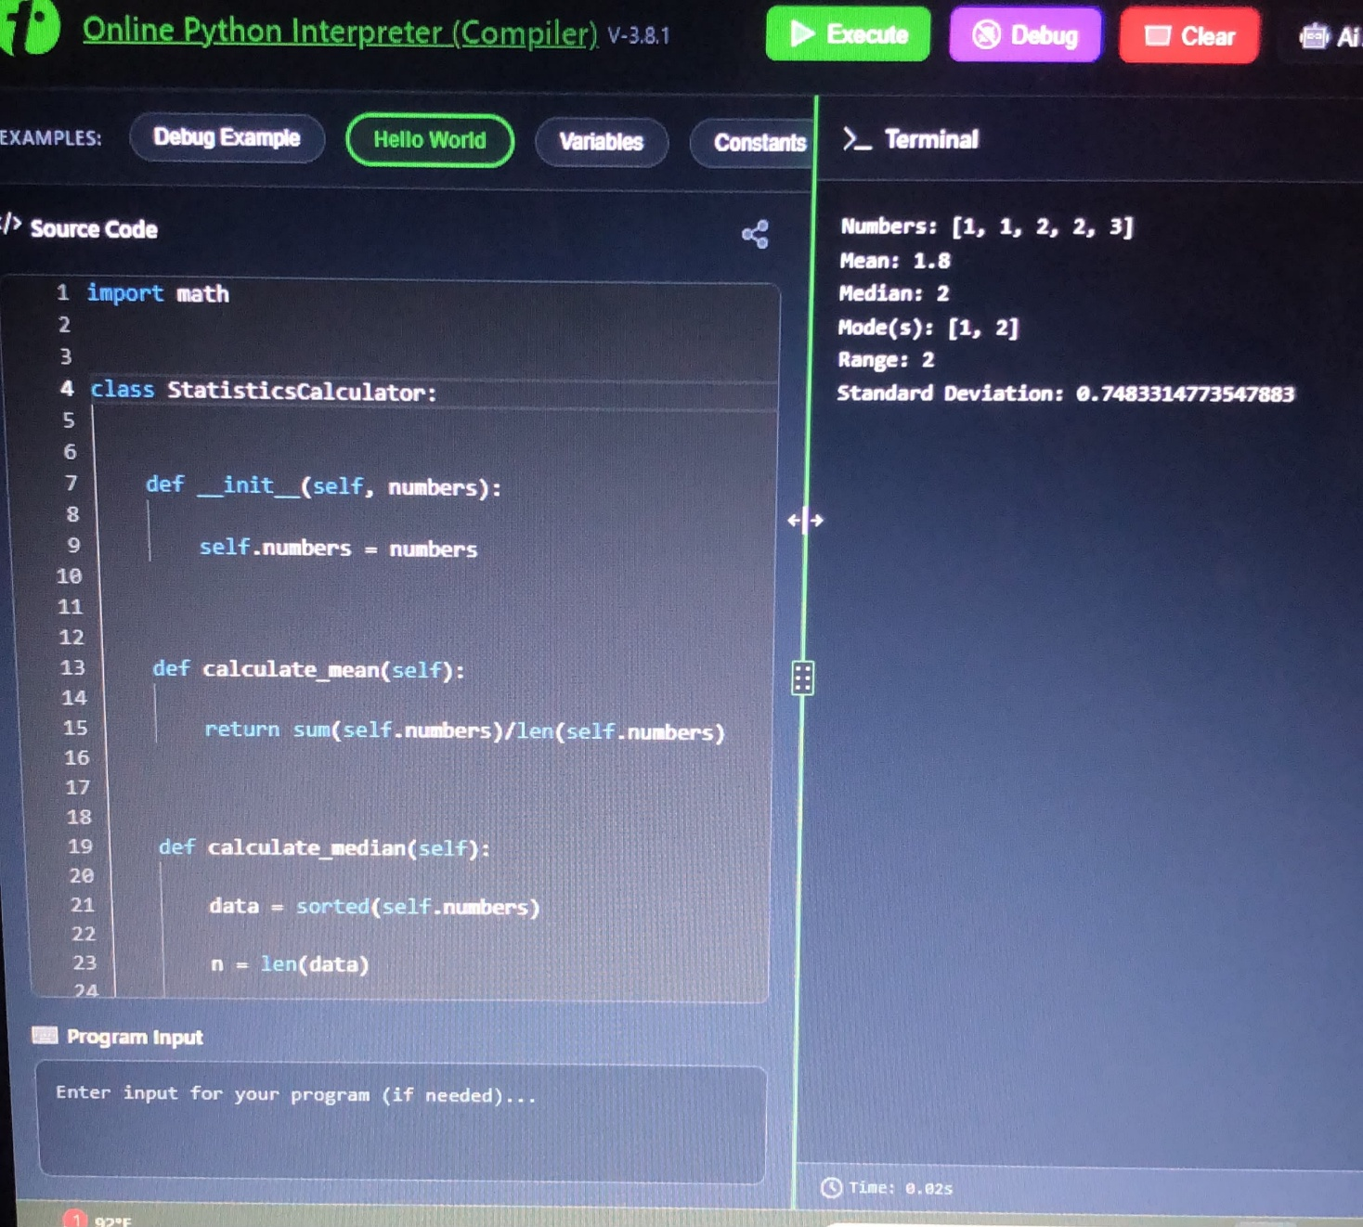

GithubLink- https://github.com/umamaz/Multi-Paradigm-Problem-Solving

